**Name: ________________________**

**Registration: ___________________**

**Design a BCD adder using as building block the 4-bit binary adder shown below. Use the provided block diagram and skeleton file to implement the BCD adder.**

| **module add4 (C, S, A, B);**  **output [3:0] S;**  **output C;**  **input [3:0] A, B;**  **assign {C, S} = A + B:**  **endmodule** |
| --- |

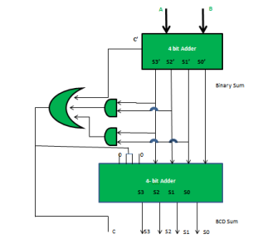

| **module bcd (C, S, A, B);**  **output [3:0] S;**  **output C;**  **input [3:0] A, B;**  **//Write your code here**  **endmodule** |
| --- |